**COMP3020 Milestone 3 Report**

**University of Manitoba - Fall 2024**

**Instructor: Ariful Islam Anik**

**Section: A02**

**Group: 10**

|  |  |  |
| --- | --- | --- |
| Skyler Pries | 7970472 | priess1@myumanitoba.ca |
| Rizaldi Wijaya | 7863004 | wijayar@myumanitoba.ca |
| Rubait Ahamed | 7876180 | ahamedru@myumanitoba.ca |
| Huzaifa Mehboob | 7889744 | mehboob1@myumanitoba.ca |

**Table of Contents**

**Table of Contents** 2

**PART (A): Technology Overview** 3

**1.** **What we used** 3

**2.** **What was our approach** 3

**3.** **What libraries were used** 3

**PART (B): Design deviations and evolutions** 3

**PART (C): Technology overview** 4

**APPENDIX (A): Figures** 6

**APPENDIX (B): Work distribution with the group** 7

**1.** **Planned Contribution** 7

**2.** **Completed Contribution** 7

**PART (A): Technology Overview**

1. **What we used**

We used HTML, CSS, and Javascript, as well as a couple of libraries to create our “Jyniper Gyms” website

1. **What was our approach**

Our approach in creating our website was: 1) We used github to maintain proper version control, 2) We used our sketches and feedback from milestone 2 as the basic idea and foundation to implement the website which proves helpful in determining the final product, and 3) pseudo-live coding to coordinate the workflow.

1. **What libraries were used**

The libraries that we used are Bootstrap, JQuery, Font Awesome, and Lottie. We used them to improve the functionality and aesthetic of our website.

**PART (B): Design deviations and evolutions**

For Huzaifa:

* Main homepage we added a profile picture button to indicate whether the user has logged in or not
* For our store we added a side nav bar (dont have this on our sketch)
* Added a back to home button for all the pages (except the store)
* That's all i can think of. Go through the sketches and compare them to our website for more details

**PART (C): Usability “sales pitch”**

Write text here. Write text here. Write text here. Write text here. Write text here. Write text here. Write text here. Write text here. Write text here. Write text here. Write text here. Write text here. Write text here. Write text here. Write text here. Write text here. Write text here. Write text here. Write text here. Write text here. Write text here. Write text here.

Write text here. Write text here. Write text here. Write text here. Write text here. Write text here. Write text here. Write text here. Write text here. Write text here. Write text here. Write text here. Write text here. Write text here. Write text here. Write text here. Write text here. Write text here. Write text here. Write text here. Write text here. Write text here.

Write text here. Write text here. Write text here. Write text here. Write text here. Write text here. Write text here. Write text here. Write text here. Write text here. Write text here. Write text here. Write text here. Write text here. Write text here. Write text here. Write text here. Write text here. Write text here. Write text here. Write text here. Write text here.

Write text here. Write text here. Write text here. Write text here. Write text here. Write text here. Write text here. Write text here. Write text here. Write text here. Write text here. Write text here. Write text here. Write text here. Write text here. Write text here. Write text here. Write text here. Write text here. Write text here. Write text here. Write text here. Write text here. Write text here. Write text here. Write text here. Write text here. Write text here. Write text here. Write text here. Write text here. Write text here. Write text here. Write text here. Write text here. Write text here. Write text here. Write text here. Write text here. Write text here. Write text here. Write text here. Write text here. Write text here.

Write text here. Write text here. Write text here. Write text here. Write text here. Write text here. Write text here. Write text here. Write text here. Write text here. Write text here. Write text here. Write text here. Write text here. Write text here. Write text here. Write text here. Write text here. Write text here. Write text here. Write text here. Write text here.

Write text here. Write text here. Write text here. Write text here. Write text here. Write text here. Write text here. Write text here. Write text here. Write text here. Write text here. Write text here. Write text here. Write text here. Write text here. Write text here. Write text here. Write text here. Write text here. Write text here. Write text here. Write text here. .

Write text here. Write text here. Write text here. Write text here. Write text here. Write text here. Write text here. Write text here. Write text here. Write text here. Write text here. Write text here. Write text here. Write text here. Write text here. Write text here. Write text here. Write text here. Write text here. Write text here. Write text here. Write text here.

Write text here. Write text here. Write text here. Write text here. Write text here. Write text here. Write text here. Write text here. Write text here. Write text here. Write text here. Write text here. Write text here. Write text here. Write text here. Write text here. Write text here. Write text here. Write text here. Write text here. Write text here. Write text here.

Write text here. Write text here. Write text here. Write text here. Write text here. Write text here. Write text here. Write text here. Write text here. Write text here. Write text here. Write text here. Write text here. Write text here. Write text here. Write text here. Write text here. Write text here. Write text here. Write text here. Write text here. Write text here.

Write text here. Write text here. Write text here. Write text here. Write text here. Write text here. Write text here. Write text here. Write text here. Write text here. Write text here. Write text here. Write text here. Write text here. Write text here. Write text here. Write text here. Write text here. Write text here. Write text here. Write text here. Write text here. Write text here. Write text here. Write text here. Write text here. Write text here. Write text here. Write text here. Write text here. Write text here. Write text here. Write text here. Write text here. Write text here. Write text here. Write text here. Write text here. Write text here. Write text here. Write text here. Write text here. Write text here. Write text here.

Write text here. Write text here. Write text here. Write text here. Write text here. Write text here. Write text here. Write text here. Write text here. Write text here. Write text here. Write text here. Write text here. Write text here. Write text here. Write text here. Write text here. Write text here. Write text here. Write text here. Write text here. Write text here.

Write text here. Write text here. Write text here. Write text here. Write text here. Write text here. Write text here. Write text here. Write text here. Write text here. Write text here. Write text here. Write text here. Write text here. Write text here. Write text here. Write text here. Write text here. Write text here. Write text here. Write text here. Write text here. Write text here. Write text here. . here. Write text here. Write text here. Write text here. Write text here. Write text here. Write text here. Write text here.

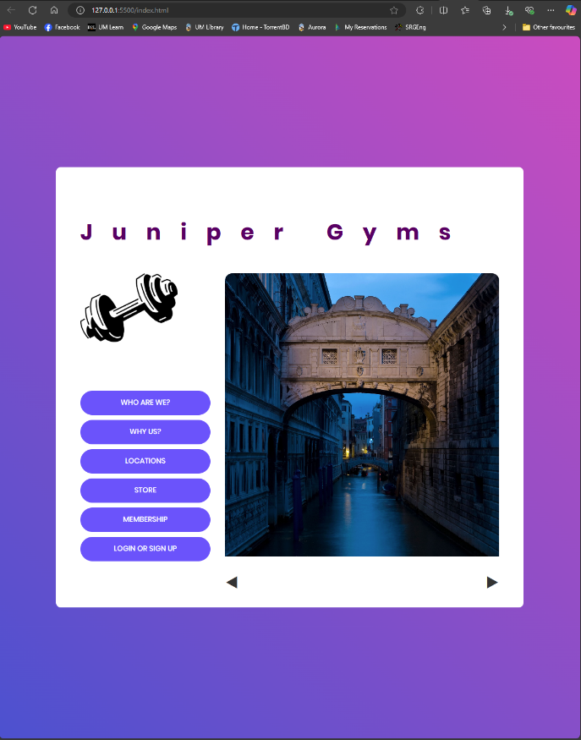**APPENDIX (A): Figures**

Figure 2:f bgb

Figure 1: scsc

Figure 3: Caption

Figure 4: Caption

**APPENDIX (B): Work distribution with the group**

1. **Planned Contribution**

|  |  |
| --- | --- |
| **Member** | **Intended Role(s)** |
| Skyler Pries | Write up |
| Rizaldi Wijaya | Write up and code |
| Rubait Ahamed | Write up and code |
| Huzaifa Mehboob | Write up and code |

1. **Completed Contribution**

|  |  |
| --- | --- |
| **Member** | **Intended Role(s)** |
| Skyler Pries |  |
| Rizaldi Wijaya | Write up and code |
| Rubait Ahamed | Write up and code |
| Huzaifa Mehboob | Write up and code |